Dr.K.Kalaiselvi-Research paper270.

*by* Kristu Jayanti College

**Submission date:** 01-Mar-2024 03:27AM (UTC-0600)

**Submission ID:** 2284424685

**File name:** Dr.K.Kalaiselvi-Research_paper-270.docx (148.47K)

**Word count:** 2118

**Character count:** 12430

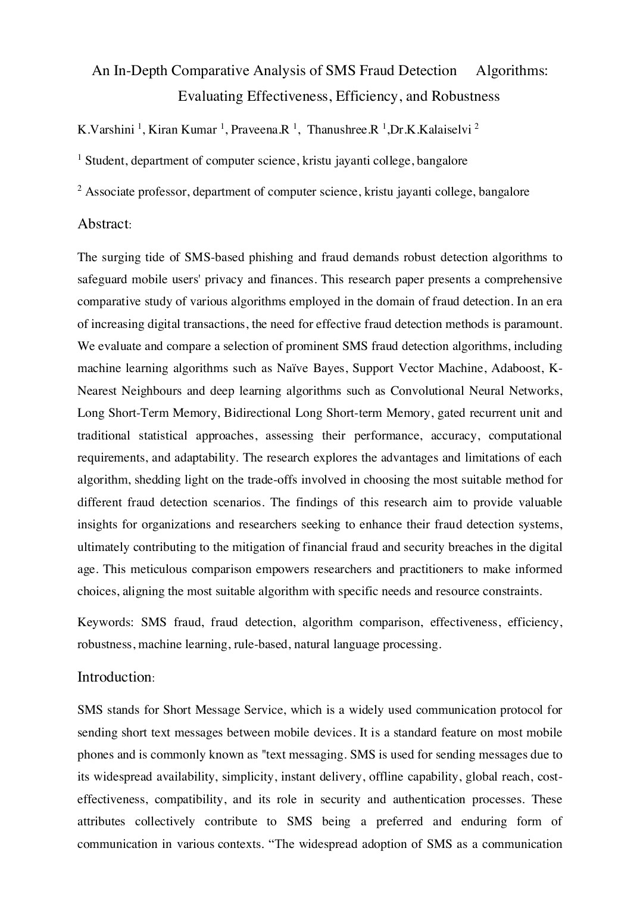

2

6

9

11

11

12

20

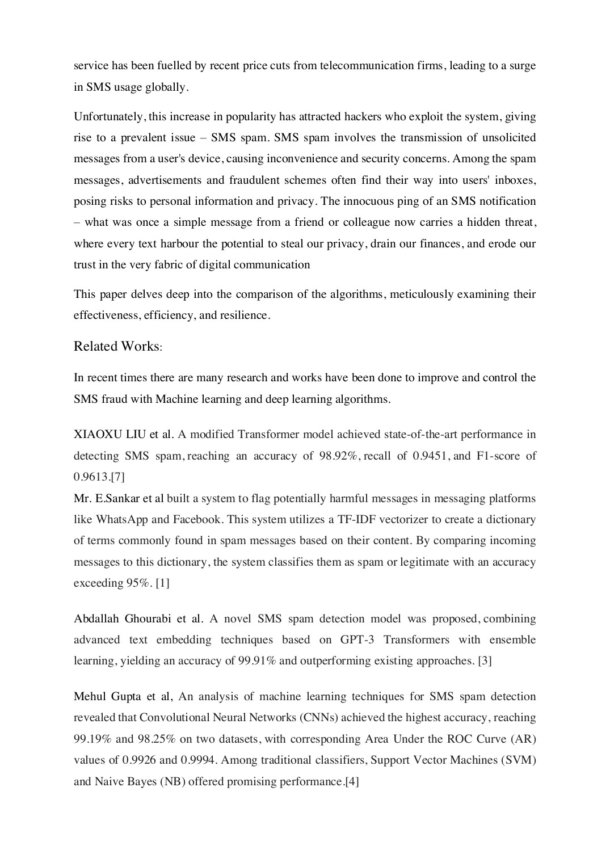

1

13

26

27

30

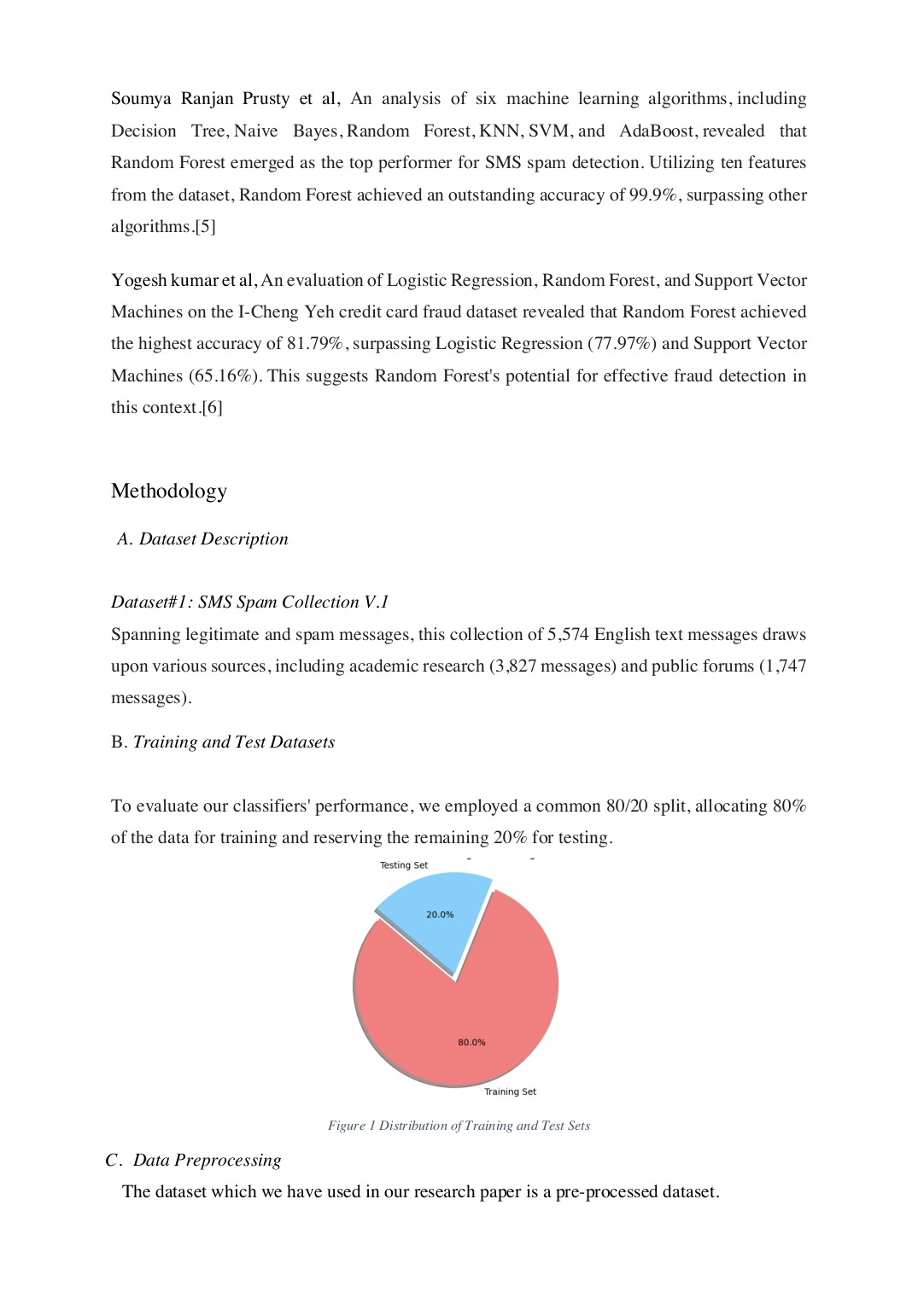

2

17

25

32

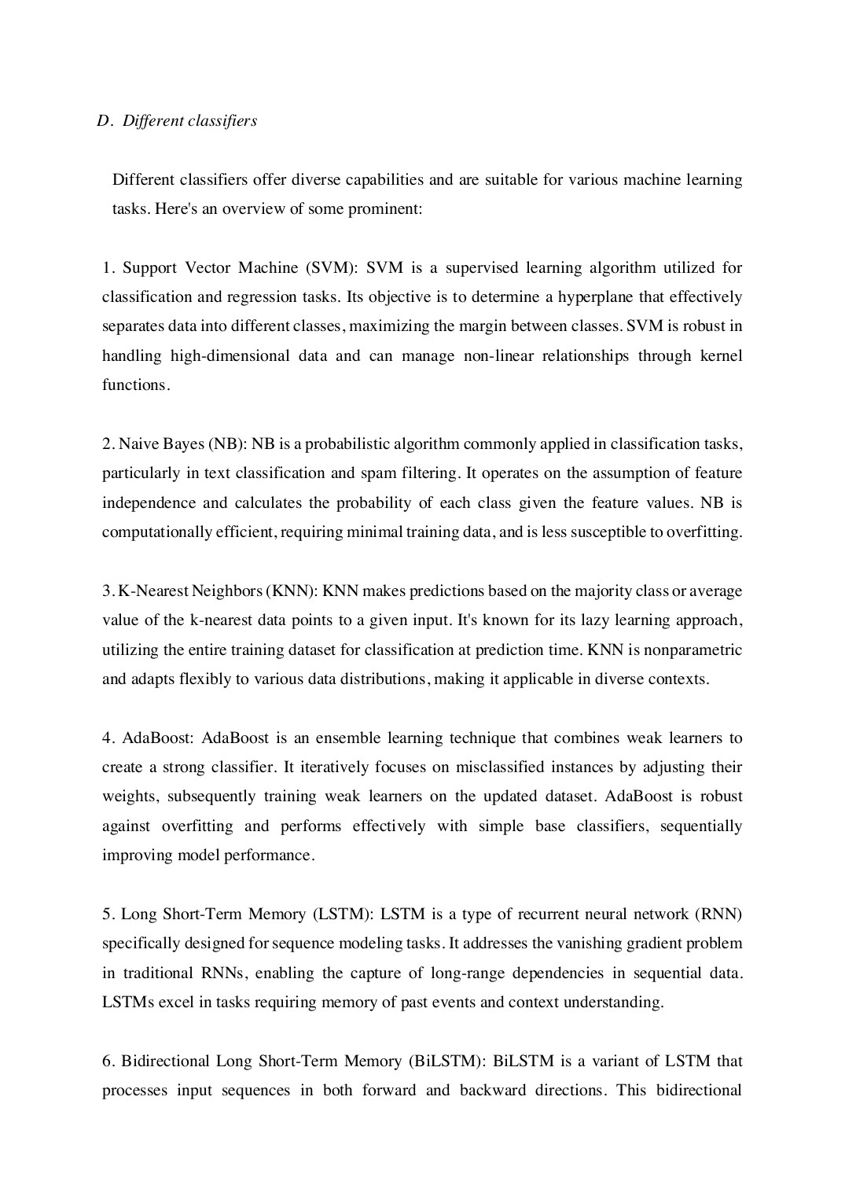

1

4

8

10

14

16

29

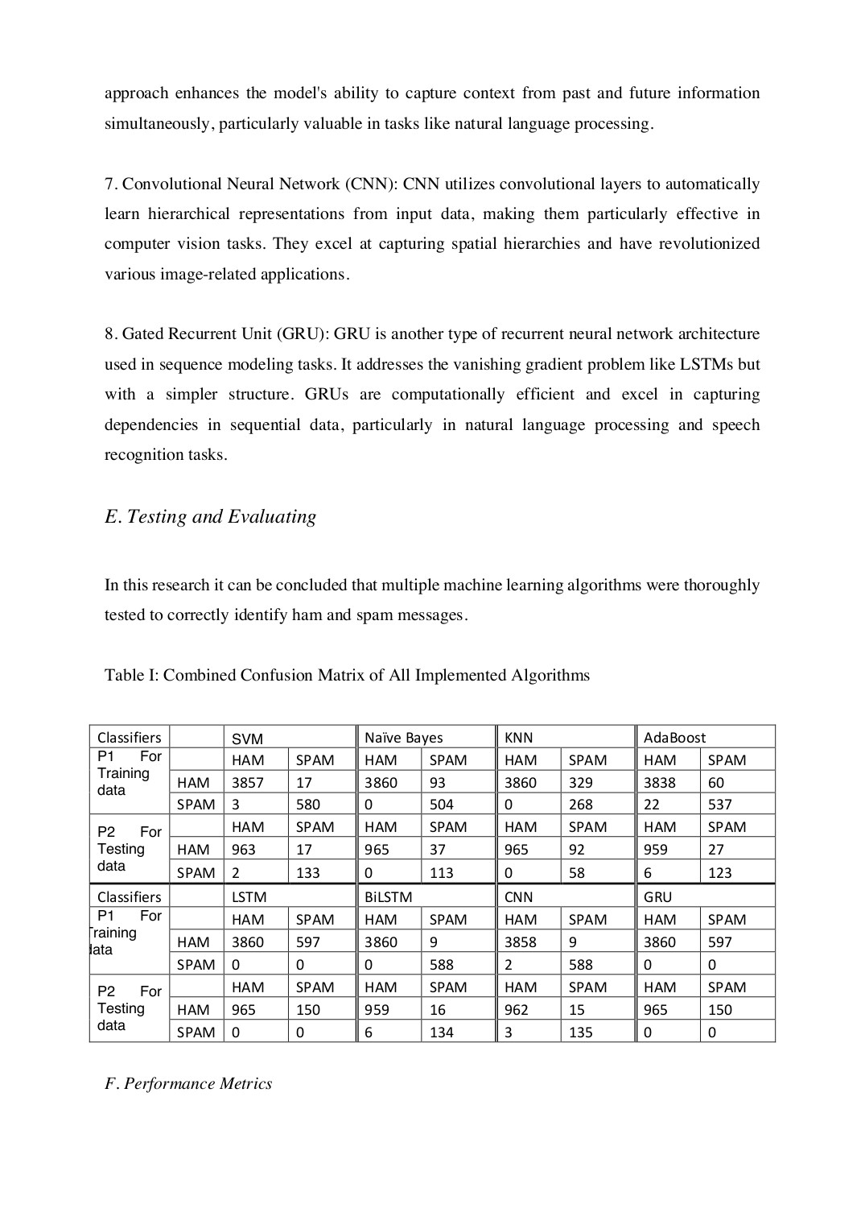

2

2

2

3

3

9

21

22

31

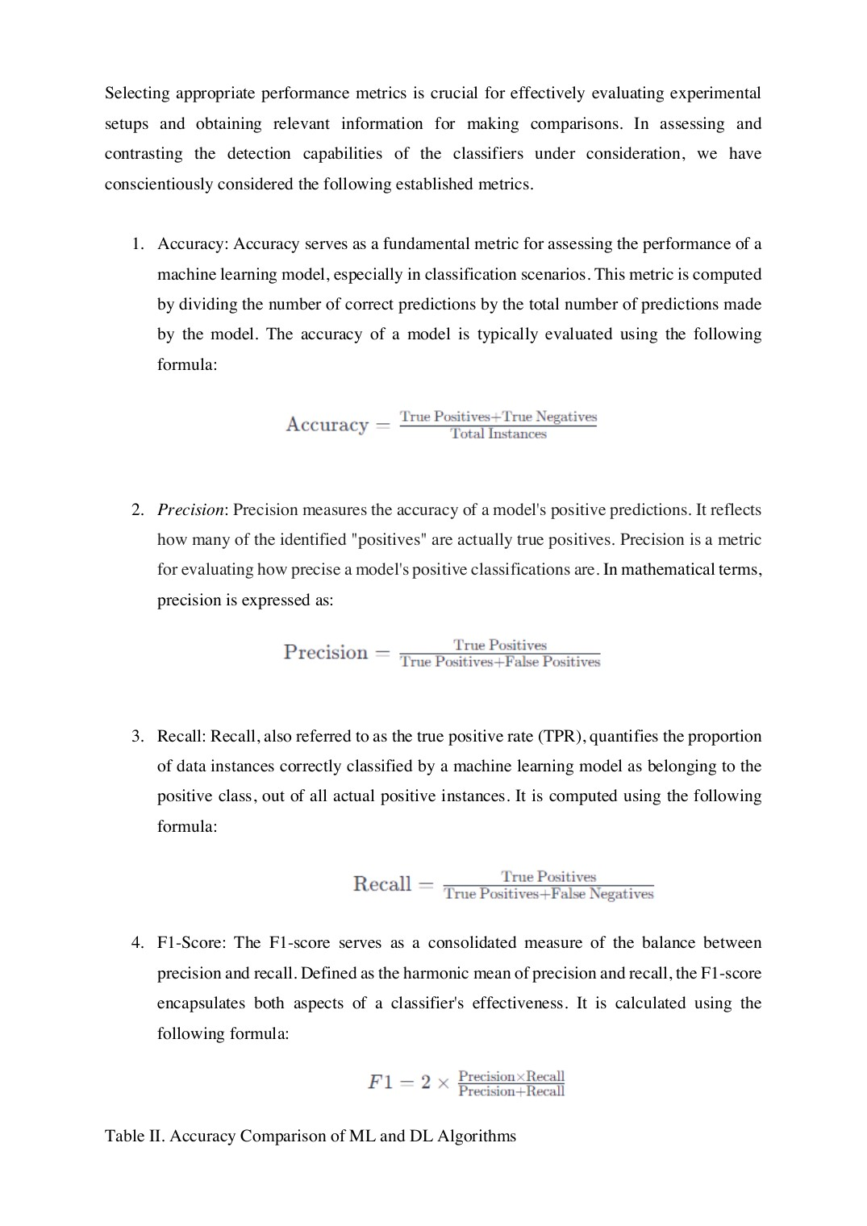

5

7

13

15

15

19

28

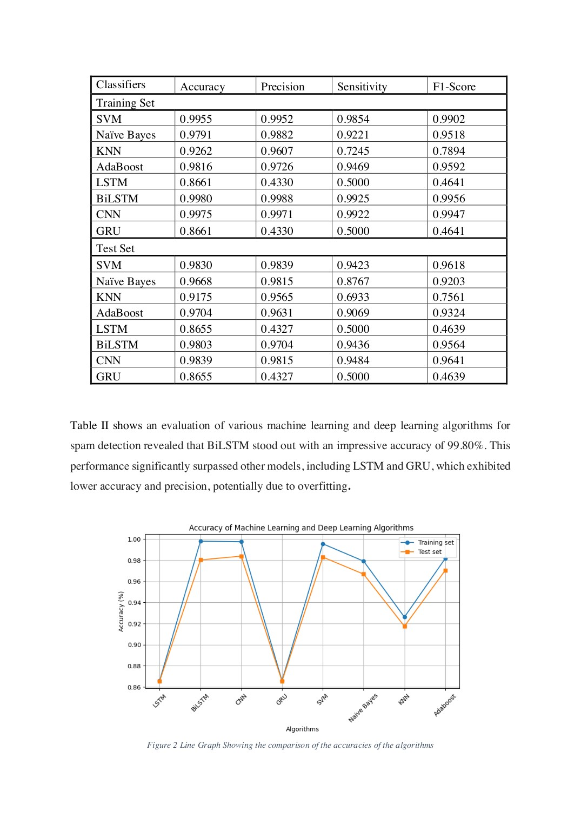

1

23

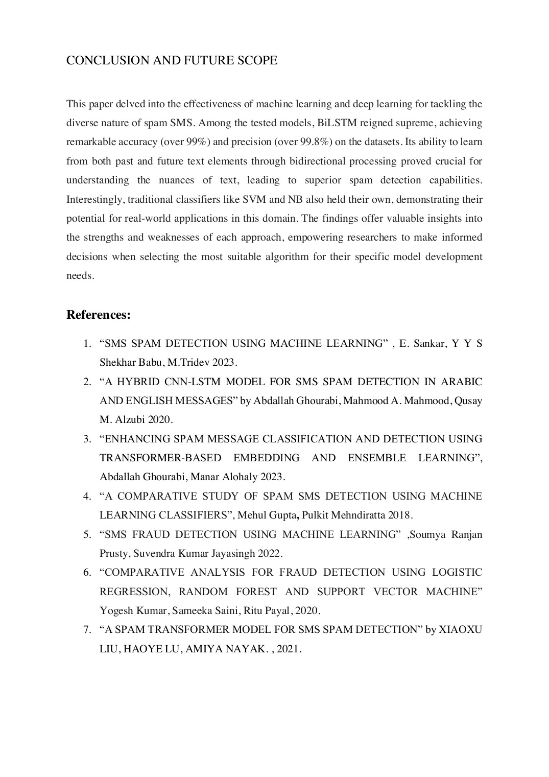

6

18

24

33

Dr.K.Kalaiselvi-Research paper-270.

ORIGINALITY REPORT

26% 19% 18% 14%

# SIMILARITY INDEX INTERNET SOURCES PUBLICATIONS STUDENT PAPERS

|  |  |
| --- | --- |
| PRIMARY SOURCES |  |
| 1 www.mdpi.comInternet Source | 2% |
| 2 www.researchgate.netInternet Source | 2% |
| 3 www.jait.usInternet Source | 1% |
| 4 Seongsoo Kim, Lei Chen, Jongyeop Kim, Yiming Ji, Rami Haddad. "A Comparative  Study of Deep Learning Models for Hyper  Parameter Classification on UNSW-NB15", 2023 IEEE/ACIS 21st International Conference on Software Engineering Research,  Management and Applications (SERA), 2023  Publication | 1% |
| 5 Submitted to University of Northumbria at Newcastle  Student Paper | 1% |
| 6 Submitted to Berlin School of Business and Innovation  Student Paper | 1% |
| 7 Submitted to National College of IrelandStudent Paper | 1% |
| 8 Submitted to University of North TexasStudent Paper | 1% |
| 9 ijisae.orgInternet Source | 1% |
| 10 Submitted to University of EssexStudent Paper | 1% |
| 11 ijrcm.org.inInternet Source | 1% |
| 12 www.nature.comInternet Source | 1% |
| 13 www.ncbi.nlm.nih.govInternet Source | 1% |
| 14 Chendan Jiang, Wentai Zhang, He Wang, Yixi  Jiao, Yi Fang, Feng Feng, Ming Feng, Renzhi  Wang. "Machine Learning Approaches to Differentiate Sellar-Suprasellar Cystic Lesions on Magnetic Resonance Imaging", Bioengineering, 2023  Publication | 1% |
| 15 Submitted to University of GreenwichStudent Paper | 1% |

16 "Machine learning based UHI dataassessment to model the relationship 1% between LULC and LST: case study of Srinagar City, Jammu & Kashmir, India", International Journal of Advanced Technology and Engineering Exploration, 2023

Publication

|  |  |
| --- | --- |
| 17 Submitted to CSU, San Jose State UniversityStudent Paper | 1% |
| 18 Manish Kumar Gupta, Rajendra Kumar Dwivedi, Annu Sharma, Mansoor Farooq,  Britto Raj S. "Performance Evaluation of  Blockchain Platforms", 2023 International Conference on IoT, Communication and  Automation Technology (ICICAT), 2023  Publication | 1% |
| 19 Sarah Farhadpour, Timothy A. Warner, Aaron E. Maxwell. "Selecting and Interpreting  Multiclass Loss and Accuracy Assessment  Metrics for Classifications with Class  Imbalance: Guidance and Best Practices",  Remote Sensing, 2024  Publication | 1% |
| 20 Submitted to University of East LondonStudent Paper | 1% |
| 21 Submitted to University of LancasterStudent Paper | 1% |

22 Dr.K. Parthiban, Mithileysh Sathiyanarayanan,Hugo Pedro Proença. "A Novel and Secured <1% Email Classification and Emotion Detection using Hybrid Deep Neural Network", International Journal of Cognitive Computing in Engineering, 2024

Publication

|  |  |
| --- | --- |
| 23 link.springer.comInternet Source | <1% |
| 24 arxiv.orgInternet Source | <1% |
| 25 ijresonline.comInternet Source | <1% |
| 26 op.niscair.res.inInternet Source | <1% |
| 27 "Abstracts of the 24th Annual State of the Art Winter Symposium", American Journal of  Transplantation, 2024  Publication | <1% |
| 28 Bsoul, Mohammad A.. "Building an Optimal Dataset for Arabic Fake News Detection",  Princess Sumaya University for Technology  (Jordan), 2023  Publication | <1% |
| 29 ebin.pubInternet Source | <1% |
| 30 ruor.uottawa.caInternet Source | <1% |
| 31 www.science.govInternet Source | <1% |
| 32 Xiaoxu Liu, Haoye Lu, Amiya Nayak. "A Spam Transformer Model for SMS Spam Detection",  IEEE Access, 2021  Publication | <1% |
| 33 "Intelligent Systems", Springer Science and Business Media LLC, 2022  Publication | <1% |

Exclude quotes Off Exclude matches Off

Exclude bibliography On